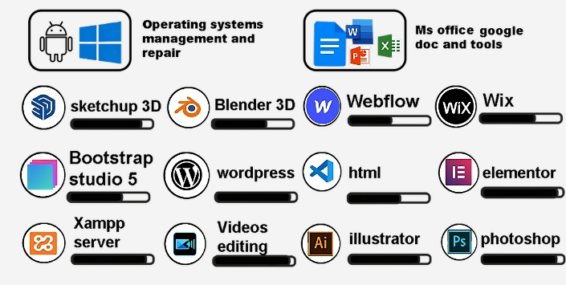
















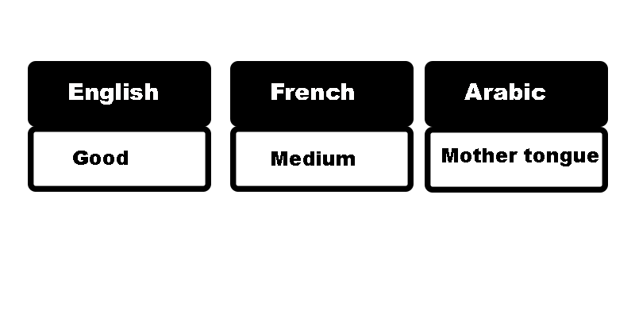


I invite you to download any cover letter in both languages from here:

https://saidnpro.github.io/home/office.html
I strive to continuously grow my technical skills and appreciate those who inspire and support my learning journey. With passion and respect, I enjoy sharing my knowledge and helping others reach their full potential and achieve their dreams.
Morocco | Rommani
Call+what +212720478379
Call+what +212615930928
saidnouasria.pro@gmail.com

https://saidnpro.github.io/home/
- Website
- Wordpress
https://saidpro.byethost7.com/
https://saidnpro.github.io/home/
All Cover letter github portfolio:
All project examples In one blog
behance.net/saidnouasria2
youtube.com/@said-nouasria
linkedin.com/in/saidnouasria/
- Freelancer graphic designer and Video Editing (2020)
- Three months of working as windows system repair and factory reset for android phones in repair shop (2019)

Moroccan nationality
Said Nouasria
22 sept 1997
Single
Creative Graphic Designer | WordPress static front-end | 3D Architectural Modeler | Video Editing & Microsoft Office – Crafting Digital Experiences and Visual Masterpieces
Said Nouasria
IT Skills

Graphic Design - WordPress design - Video Editing - 3D Design – office tools -MS word excel and powerpoint - Operating system installation (Windows), troubleshooting, software maintenance – Anydesk remote desktop- pdf editing - awesome powerpoint presentations design

Work Experience

- One year of working as a photoshop designer in a library of designing and printing Tanger (2023)

Hobbies
Language :
internet
Travel
- Level Baccalaureate: science of life and earth 2018.

Photoshop (certificate) | Office 365
Semantic HTML and CSS . | Illustrator 2021 Quick Start
Adobe Premiere Pro. | WordPress : L’installation
Sketchup 3D. | google the digital marketing 2019.

- Linkedin learning certificate and google certificate:
.

- Diploma of studying electrical of building office of vocational training and labor promotion 2024.

Education

Professional Summary

